|  |  |  |
| --- | --- | --- |
| IBM-Logo - Chicago Innovation | DGT introduces high end diploma courses - digitalLEARNING Magazine | Edunet Foundation-Delhi- CSR Organization profile |

Project Report on

**SOCIAL NETWORKING WEBSITE   
(Professional Networking and Job Search Platform)**



Submitted in partial fulfillment of completion of the course

**Advanced Diploma in IT, Networking and Cloud Computing**

SESSION: - 2022-2024

From

**National Skill Training Institute, Bengaluru**

**Submitted By:**

Keerti Vishwkarma

Ajay Kumar

Sushmitha P.

**Under Guidance Of:**

Mrs. Swathi K. (IBM Mentor)

Mr. Ankur Mishra (Edunet Mentor)

**Abstract**

This project, **JobHive**, is a professional networking platform developed using **Spring Boot** that integrates social networking features with a job search board. Similar to platforms like LinkedIn, JobHive enables users to build professional connections, showcase their skills and experience, and apply for jobs. The platform provides users with a streamlined interface to create detailed profiles, post job listings, search for jobs, and communicate with other professionals through a messaging system.

JobHive addresses the growing need for an online space where job seekers, employers, and professionals from various industries can interact efficiently. Current job platforms are either too general or focused on specific industries, which often leads to challenges in networking and finding suitable job opportunities. JobHive aims to fill this gap by offering industry-specific networking, skill-based job recommendations, and a user-friendly experience tailored to professionals looking to advance their careers.

The platform leverages **Spring Boot** for backend development, **Thymeleaf** for dynamic content generation, and **MySQL** for database management. It ensures security through **Spring Security** and handles user authentication, authorization, and data protection. JobHive includes key features such as user profiles with detailed information, job posting and application functions, and a direct messaging system for professional communication.

One unique aspect of JobHive is its **AI-driven job-matching algorithm**, which analyzes users' profiles and suggests jobs that align with their skills and experience. The platform also incorporates customizable networking features that allow users to filter potential connections based on industries, skills, or location, making it easier to build meaningful professional relationships.

Despite its current success, JobHive has some limitations, such as the lack of a mobile app and integration with third-party job platforms like LinkedIn and Indeed. Future improvements will focus on building a mobile version, integrating APIs for external job platforms, and enhancing the AI capabilities to improve job matching and career coaching features.

In conclusion, JobHive offers a modern solution for professionals to connect, network, and advance their careers through an easy-to-use platform. It not only simplifies the job search process but also fosters professional relationships that help users grow in their respective industries. Through continuous development and future enhancements, JobHive aims to become a leading platform for professional networking and job search.

**Acknowledgement**

We would like to extend our heartfelt gratitude to all those who contributed to the success of our project, **JobHive** — a LinkedIn-like professional networking platform developed using Spring Boot.

First and foremost, we express our deep appreciation to **Mrs. Swathi K.**, our **IBM Mentor**, for her continuous guidance and support throughout the development of this project. Her expert advice, valuable insights, and encouragement have been pivotal in helping us navigate through various challenges. She provided us with the technical knowledge and feedback necessary to improve our project at every step.

We are also extremely thankful to **Mr. Ankur Mishra**, our **Edunet Mentor**, who offered immense technical support, helped us refine our ideas, and guided us in structuring the project. His mentorship, especially in areas such as backend development, project architecture, and best coding practices, was crucial in ensuring that we maintained a high standard of quality in our work. His dedication to helping us succeed motivated the entire team to push our boundaries.

A special thank you goes to our project team members: **Keerti Vishwkarma**, **Sushmitha P.**, and **Ajay Kumar**. This project would not have been possible without their hard work, collaboration, and dedication. **Keerti**, with her expertise in both frontend and backend development, played a major role in database design and deployment. **Ajay** was instrumental in frontend development and ensuring the platform’s visual appeal, while **Sushmitha** handled documentation and resource management efficiently. Each team member’s unique contribution made this project a success.

We would also like to acknowledge the **IBM SkillsBuild program** and the **Tech Buddies initiative** for offering this learning platform, which provided us with essential skills in software development. Through this experience, we gained hands-on knowledge of technologies such as Spring Boot, MySQL, and front-end frameworks, which allowed us to successfully complete the project.

Finally, we are grateful for the support of our friends, family, and peers who encouraged us throughout this journey. Their understanding and motivation gave us the energy to focus on this project and see it through to the end.

This project has been a great learning experience for us, and we are proud of what we have achieved together as a team. We hope that **JobHive** will serve as a useful tool for professional networking and job search in the future. Thank you to everyone who made this project possible.

**Team Composition and Workload Division**

Our project was developed by a dedicated team of three members: **Keerti Vishwkarma**, **Ajay Kumar**, and **Sushmitha P.** Each team member played a significant role in the successful completion of the professional networking platform.

1. **Keerti Vishwkarma -** She handled both **frontend, backend development and** **database management** and was responsible for designing the platform’s user interface using HTML, CSS, JavaScript, and Thymeleaf. On the backend, Keerti worked extensively with **Spring Boot**, managing the database integration and API development. She also took charge of the deployment process, ensuring the platform was hosted and functional on the server.
2. **Ajay Kumar** **-** Ajay focused primarily on **frontend development** and **database management**. He was responsible for designing interactive UI elements, ensuring the platform was user-friendly and responsive. He also contributed to the backend by working on database-related tasks, including managing user data and job posts.
3. **Sushmitha P. -** Sushmitha’s contributions were essential in gathering **resources** and managing the project’s **documentation**. She ensured that the project met its deadlines and handled the technical write-ups, diagrams, and reports.

Together, the team worked seamlessly to build a functional and efficient professional networking platform.

**Table of Contents**

1. Introduction to Problem
2. Literature Review
3. Proposed Solution
4. Requirements

4.1 Technology Stack

4.2 Hardware

4.3 Software

4.4 Deployment Environment

5. User Requirements

6. Design Documentation

7. Implementation Details

8. Testing

9. Deployment

10. Future Scope

11. Conclusion

Appendix A Project Code

Appendix B Screenshot of Project

Appendix C abbreviation

References

1. **Introduction to Problem**

In today’s job market, online platforms like LinkedIn and indeed play a significant role in connecting professionals with job opportunities. However, these platforms often present challenges for users seeking specific industry-related networking and job postings. Many current job search websites are either too broad or overly specialized, making it difficult for users to find tailored connections and relevant opportunities that align with their unique skills and professional goals.

The fragmentation of the professional networking ecosystem has created a gap where job seekers, employers, and industry experts struggle to build meaningful connections. Job seekers face the problem of standing out in a crowded market, while employers find it difficult to source talent that fits their precise requirements. Similarly, professionals looking to grow their network often find it challenging to connect with individuals who share similar interests or career aspirations.

This project addresses the need for a simplified and more focused platform that combines professional networking and job search functionalities. Unlike traditional platforms that are either too general or too industry-specific, our solution aims to create a space where users can build their professional profiles, make relevant connections, and discover job opportunities that are more closely aligned with their career goals.

The goal of this project is to build a professional networking website, **JobHive**, which integrates job listings, professional connections, and communication tools all in one platform. By offering a streamlined, user-friendly experience, **JobHive** will allow users to effectively showcase their skills, connect with others in their industry, and apply for suitable job openings. This platform is intended to bridge the gap between professionals and job opportunities, ultimately helping users advance their careers.

**2. Literature Review**

In recent years, the development of social networking platforms has evolved significantly, with a focus on enhancing user interaction and engagement. Platforms like LinkedIn and Indeed serve as prominent examples, allowing users to connect, share professional experiences, and discover job opportunities. The core functionalities of these platforms include user profiles, connection management, messaging systems, and notifications, which facilitate seamless communication among users.

Java-based technologies, particularly Spring Boot, have gained popularity for building robust backend services for web applications. Spring Boot simplifies the development process by providing a framework that allows developers to create stand-alone, production-grade applications with minimal configuration. Additionally, Thymeleaf, a modern server-side Java template engine, is often used for rendering dynamic web pages, making it easier to display user data and interact with the backend.

Object-oriented programming (OOP) principles play a crucial role in structuring the codebase for such applications. OOP facilitates code reusability, maintainability, and scalability by allowing developers to create modular components that encapsulate data and behaviour. Features such as inheritance and polymorphism enable developers to build complex systems while keeping the code organized and manageable.

Moreover, the integration of modern web technologies, such as RESTful APIs, allows for efficient data exchange between the client and server, improving the overall user experience. By leveraging these technologies and methodologies, developers can create feature-rich social networking applications that cater to the needs of users, providing them with valuable tools for professional networking and communication.

In summary, the literature underscores the importance of leveraging Java frameworks, OOP principles, and modern web technologies in building effective social networking platforms, which ultimately enhances user engagement and satisfaction.

**3. Proposed Solution**

The proposed solution for the social media application focuses on creating a robust platform for users to connect, share, and communicate. The architecture is built using Java with Spring Boot, Thymeleaf, and a MySQL database to ensure seamless functionality and user experience.

**1. User Profile Management**

* **Create Professional Profile**: Users can create a detailed professional profile by adding personal details, skills, experience, and education. This profile will also allow for the upload of profile and background images.
* **Generate Unique Profile URLs**: Each user will have a unique profile URL (e.g., http://localhost:8080/profile/keerti-sharma-nkPVoxS9UEk) to enhance personal branding and easy sharing.

**2. Content Creation**

* **Create Posts**: Users can create text-based posts to share updates or thoughts with their connections, including image attachments.
* **Create Articles**: Users can write and publish longer articles that showcase expertise, allowing rich formatting and multimedia integration.

**3. Event Management**

* **Create Events**: Users can organize events, inviting connections and allowing them to RSVP.
* **Show Event Details**: Users can view event descriptions, including date, time, location, and attendees.

**4. Search Functionality**

* **Search for Posts**: Users can search for posts by keywords, tags, or authors, facilitating content discovery.
* **Search for Articles**: Similar to posts, users can search for articles based on topics, titles, or authors.
* **Search for Events**: Similar to articles, users can search for events based on event names and description.
* **Search for Users**: Similar to events, users can search for users based on their first or last names.

**5. User Interaction**

* **Follow/Unfollow Users**: Users can follow other users to receive updates on their activities and unfollow to stop receiving notifications.
* **Like Posts and Articles**: Users can express appreciation for posts and articles by liking them.

**6. Comments and Replies**

* **Comment on Posts**: Users can comment on posts to engage with the content and share opinions.
* **Comment Replies**: Users can reply to comments, creating a threaded discussion for better interaction.

**7. Connection Management**

* **Connect with Other Users**: Users can send connection requests to other users, expanding their professional network.
* **Manage Connection Requests**: Users can accept or reject connection requests, allowing control over their connections.

**8. Email Verification**

* **Send Verification Emails**: After registration, users will receive an email to verify their accounts, enhancing security and data integrity.

**9. Contact Form**

* **User Contact Form**: Users can fill out a contact form to reach out for support or inquiries.
* **Admin Notification**: Admins receive notifications of new inquiries submitted through the contact form.

**10. Profile Viewing**

* **Show Other Users’ Profiles**: Users can view the profiles of their connections or other users to learn more about their backgrounds and skills.

**11. Messaging System**

* **Messaging with Connections**: Users can send private messages to their connections for direct communication.
* **Notification of New Messages**: Users will receive notifications when they receive new messages from connections.

**12. Notification System**

* **Notify Connections of New Posts**: Connections are notified when a user creates a new post, ensuring engagement.
* **Notify for Comments and Likes**: Users receive notifications when their posts are commented on or liked.

**13. Job Management**

* **Create Job Listings (CRUD)**: Companies can create, read, update, and delete job postings to attract candidates.
* **Show Applicants**: Employers can view applicants for their job postings, reviewing resumes and applications.

**14. Resume Handling**

* **Download Resumes**: Employers can download resumes of applicants for offline review.
* **Apply for Jobs**: Users can apply for jobs directly through the platform by submitting their resumes and cover letters.

**15. User Skills**

* **Add Skills**: Users can list their professional skills on their profiles to highlight their expertise.

**16. Activity Feed**

* **User Activity Feed**: Users can view a feed of activities performed by their connections, including posts, comments, and new connections.
* **Filter Activity**: Users can filter the activity feed to see specific types of activities (e.g., only posts or connections).

**17. User Experience Enhancements**

* **Responsive Design**: The website will be designed for optimal viewing on various devices, including mobile and tablets.
* **User-Friendly Interface**: A clean and intuitive UI will be implemented to enhance user interaction and satisfaction.

**18**. **Scalability and Performance**

* The backend is designed for scalability, allowing future growth in user numbers and features. Using efficient database queries and data retrieval methods, the application ensures quick response times and smooth operation.

**19. Multi Language Support**

* Multi-Language Support enables applications to offer content and functionality in multiple languages, enhancing user experience and accessibility globally.

1. **Requirements**

**4.1 Technology Stack**

**1. Frontend Technologies**

* **HTML**: Used for structuring the web pages and content.
* **CSS**: Used for styling the web pages and ensuring a visually appealing design.
* **Bootstrap**: A responsive framework that helps in creating mobile-first web designs and provides pre-built components.
* **JavaScript**: Used to add interactivity and dynamic behaviour to the web pages.
* **JQuery**: A JavaScript library that simplifies DOM manipulation and event handling, enhancing user experience.

**2. Backend Technologies**

* **Java**: The primary programming language for server-side development.
* **Spring Boot**: A framework for building Java applications, providing built-in functionalities for web applications and RESTful APIs.
* **Thymeleaf**: A server-side Java template engine for rendering dynamic HTML content based on server-side data.

**3. Database**

* **MySQL**: A relational database management system used to store user data, posts, events, and other application-related information.

**4. Development Environment**

* **XAMPP**: A free and open-source cross-platform web server solution stack package that allows developers to run applications and MySQL databases locally.

**4.2 Hardware**

**1. Server Requirements**

* **Processor**: Dual-core processor (e.g., Intel Core i3 or equivalent).
* **RAM**: Minimum 8 GB RAM for smooth operation and handling multiple user requests.
* **Storage**: At least 100 GB of available storage to accommodate the database, application files, and user-uploaded content.

**2. Client Requirements**

* **User Devices**: Desktops, laptops, tablets, or smartphones with internet access to use the application.

**4.3 Software**

**1. Operating System**

* Windows, macOS, or Linux for the development environment and server deployment.

**2. Development Tools**

* **Integrated Development Environment (IDE)**: Spring Tools Suite (Version: 4.24.0.RELEASE) or Eclipse for Java development (Version: 2024-03 (4.31.0)).
* **Database Management Tool**: phpMyAdmin for managing the MySQL database.

**3. Version Control**

* **Git**: For source code management and collaboration among developers.

**4.4 Deployment Environment**

* **Hosting Plan**: Choose a suitable shared or VPS hosting plan from Hostinger based on traffic expectations and resource requirements.
* **Server Setup**: Configure the server environment with required PHP and MySQL versions.
* **Domain Name**: Register a domain name to host the website and make it accessible on the internet.
* **Deployment Tools**: Use FTP or a control panel provided by Hostinger to upload the application files and configure the web server.
* **Database Setup**: Create a MySQL database on Hostinger, importing the local database schema and data.
* **Environment Configuration**: Adjust configuration files (like application.properties for Spring Boot) to connect to the live database and handle production settings.

**5. User Requirements**

The social media website aims to provide users with a comprehensive platform for professional networking and content sharing. Users require the ability to create and manage their professional profiles.

1. **User Registration and Authentication**
   * Users should be able to register using their email and create a secure password.
   * A verification email must be sent after registration to confirm user identity.
2. **User Profile Creation**
   * Users should create and update their professional profiles, including personal details, skills, education, and work experience.
   * Users can upload profile and background images to enhance their profiles.
3. **Content Interaction**
   * Users should create and share posts, articles, and events.
   * The ability to like, comment, and reply to comments on posts and articles.
4. **Search Functionality**
   * Users should search for posts, articles, events, and other users easily.
   * Filters should be available to refine search results.
5. **Connection Management**
   * Users should connect with other users by sending and accepting connection requests.
   * Users can follow or unfollow others to manage their feeds.
6. **Messaging System**
   * Users should send private messages to their connections.
   * Notifications for new messages and interactions (likes, comments) on posts.
7. **Job Listings**
   * Users should browse job postings, apply for jobs, and upload resumes.
   * Employers can view applicants and manage job listings.
8. **Responsive Design**
   * The website must be accessible and user-friendly on desktops, tablets, and smartphones.

These requirements focus on providing a seamless, engaging experience for users while ensuring their data security and privacy.

**6. Design Documentation**

The design documentation for the social media website outlines the architecture and components involved in the system. At the core of the design are the User Interface (UI), which provides an interactive platform for users, and the Server, which handles application logic and communication with the database.

The database stores user profiles, posts, events, messages, and notifications, ensuring data integrity and quick access. User authentication is crucial for security, allowing users to register, log in, and manage their profiles safely.

Data flows from the UI to the Server through HTTP requests, enabling actions like creating posts or sending messages. The Server then interacts with the database using SQL queries to fetch or update data as needed. The design also accommodates job listings, allowing users to create, apply for, and manage job applications.

The accompanying diagram illustrates these components and their interactions, showcasing the system's architecture and ensuring a clear understanding of data flow throughout the application.

To design a professional networking platform in **Figma** based on the content provided, here’s a general outline of the structure and functionality, focusing on key sections like **user profiles**, **job posting**, **connections**, and **messaging**. Each section will contain links to interactive elements and visual components such as images, buttons, and icons.

<https://www.figma.com/design/UqQgRKPVUQFPdcIWVB5Ry0/JobHive?node-id=0-1&t=ScycJz8YQT0ee6dd-1>

### Data Flow Overview

1. **User Interaction**: Users interact with the UI (create posts, send messages).
2. **Server Communication**: The UI sends HTTP requests to the server.
3. **Database Queries**: The server executes SQL queries to retrieve or update data in the database.
4. **Data Response**: The server sends responses back to the UI, displaying updated information to the user.

This structured approach ensures a robust, user-friendly experience while maintaining security and performance standards.

### Flow Chart

1. **User Registration**

Verify email address (send verification link on email)

Create user account if verification is successful

Collect user information (email, password, name, etc.)

1. **Use Login**

Verify credentials against database

Grant access if credentials are correct

Collect user credentials (Email and Password)

1. **Create Profile**

Provide option to upload profile and background image

Save profile information to database

Allow user to input personal details, skills, experience and education

1. **Create Posts, Articles and Events**

Provide input fields for title, content and other details

Save Content to the database

Allow user to select content type (Post, Event, Article)

1. **Search and Discover**

Provide options to follow users or like/comment on content

Display search results based on keywords or filters

Allow user to search for posts, events and users

1. **Social Interactions**

Notify users of new activities (follows, likes, comments, etc.)

Allow users to follow, unfollow, like, comment and reply to comments

1. **Messaging**

Allow users to send and receive messages within their network

Notify users of new messages

1. **Jobs and Applications**

Allow users to apply for jobs and upload resumes

Notify job creators of new applications

Allow users to create and manage job postings

1. **Contact Form**

Provide a contact form for users to submit inquiries or feedback

Save data to the database

1. **Logout**

Remove any stored user data from the server-side session

Redirect to Login Page

User initiates logout action (Click Logout Button)

**7. Implementation Details**

The social media application is built using the Spring Boot framework, which allows for rapid development and easy integration with various components. The application utilizes the Model-View-Controller (MVC) architecture, with Thymeleaf as the templating engine for rendering dynamic web pages.

1. **Project Structure**

The project is organized into several modules, each focusing on a specific feature or functionality, making it easy to manage and maintain.

1. **User Authentication**

Spring Security is implemented for user authentication and authorization. Users can register, log in, and manage their profiles. Passwords are securely hashed before storage.

1. **Database Management**

MySQL is used as the relational database to store user data, posts, comments, and connections. JPA (Java Persistence API) is utilized for database interactions, making it easier to perform CRUD operations.

1. **Messaging and Notifications**

The application includes real-time messaging and notification features, enabling users to connect and engage with each other. Web Socket technology is used for live messaging, while notifications are stored in the database and retrieved when users log in.

1. **User Interface**

The front-end is designed with Bootstrap for responsiveness, ensuring a seamless experience across devices. Custom styles are applied to match the branding and functionality requirements.

1. **API Integration**

RESTful APIs are designed for interaction with front-end components, allowing for data retrieval and submission without full-page reloads.

**8. Testing**

Testing is crucial to ensure the application's reliability and functionality. Different types of testing are conducted:

1. **Unit Testing**

Each component, such as services and repositories, is tested individually using Junit to ensure they work correctly.

1. **Integration Testing**

The interaction between various components (like database access and controllers) is tested to ensure data flows correctly throughout the application.

1. **End-to-End Testing**

Simulated real user scenarios to ensure that workflows like project creation, mentor feedback, and resource allocation worked as expected.

1. **Performance Testing**

Load testing is performed to ensure the application can handle multiple users simultaneously without performance degradation.

**9. Deployment**

Deploying the application on Hostinger involves several steps:

1. **Setting Up Hosting**

Choose a suitable hosting plan that supports Java applications. Hostinger provides options for VPS or dedicated hosting that can run Java applications.

1. **Configuring the Server**

Install necessary software like Java, Tomcat, and MySQL on the server. Ensure that the environment is set up to support your application's requirements.

1. **Uploading the Application**

Package the Spring Boot application as a JAR or WAR file and upload it to the server using FTP or SSH.

1. **Database Setup**

Create the MySQL database on the server and import any initial data if necessary.

1. **Running the Application**

Start the application using a command line or through a control panel provided by Hostinger. Ensure that it runs correctly and is accessible via the web.

1. **Monitoring and Maintenance**

Regularly monitor server performance, apply updates, and back up data to maintain application health.

**10. Future Scope**

The future scope of this professional networking platform is promising, with numerous enhancements and features planned to ensure growth and improved user engagement:

1. **Mobile Application**
   * **Feature** **-** Develop a mobile application using frameworks like **React Native** or **Flutter** to provide a seamless experience across devices.
   * **Benefit** **-** A mobile app will broaden the platform's reach, allowing users to engage on-the-go, increasing daily active users and user retention.
2. **Advanced Features**

* **Feature** **-** Incorporate **live streaming**, **video sharing**, and **polls** to keep users engaged and encourage more interactive content creation.
* **Benefit** **-** These features will foster a dynamic community, allowing users to share knowledge, create discussions, and host webinars, making the platform more engaging and valuable for professionals.

1. **AI and Machine Learning**

* **Feature** **-** Implement **AI-driven algorithms** for personalized job recommendations, user behaviour analysis, and enhanced security measures such as fraud detection.
* **Benefit** **-** AI will improve the user experience by offering tailored job opportunities, suggesting relevant connections, and ensuring the platform remains secure, enhancing overall user satisfaction and security.

1. **Localization and Internationalization**

* **Feature** **-** Expand the platform to support **multiple languages** and adapt it for various regions.
* **Benefit** **-** Localization will attract a global audience, offering a personalized experience for users in different countries and broadening the platform’s market reach.

1. **Integration with Other Services**

* **Feature** **-** Explore partnerships with third-party services for **payment processing**, **advertising**, and **analytics** integrations.
* **Benefit** **-** These integrations will enable additional revenue streams through job posting fees, targeted advertisements, and paid features, while offering more value-added services to users.

1. **Enhanced User Privacy and Security**

* **Feature -** Continuously improve **privacy** and **security measures** to protect user data, especially as the platform scales.
* **Benefit -** Enhanced security features will build user trust and confidence, ensuring the platform is secure against data breaches and complies with global privacy standards, crucial for retaining users and maintaining legal compliance.

These future enhancements will ensure the platform remains competitive, scalable, and valuable for its users, fostering professional growth and meaningful connections.

These developments can significantly improve user experience and expand the platform’s reach, ensuring its sustainability and relevance in the competitive social media landscape.

**10. Conclusion**

The development of our **JOBHIVE** project using Spring Boot has been a rewarding and insightful experience. Throughout the project, we aimed to create a professional networking platform that allows users to build connections, search for job opportunities, and interact with other professionals in a seamless and efficient manner. By integrating essential features such as user profiles, job postings, and messaging, we have built a strong foundation for a platform that caters to the needs of job seekers, employers, and professionals alike.

The use of **Spring Boot** as the backend framework enabled us to create a scalable and secure system, while **MySQL** helped us manage large amounts of user data, including profiles, jobs, and connections. We also implemented **Spring Security** to ensure secure authentication and data handling, which is crucial for a professional networking platform. **Thymeleaf** was used for dynamic content rendering on the frontend, ensuring a smooth user experience.

Despite the challenges we faced, such as managing complex user interactions and integrating various components, the project was a success. Our team worked collaboratively, with each member contributing their expertise in different areas such as frontend development, backend programming, database management, and documentation.

Looking ahead, we recognize several areas for future improvements. Enhancements like **mobile application development**, **AI-based job matching**, and integration with external job platforms like LinkedIn and indeed will further strengthen the platform's capabilities. Additionally, implementing advanced networking features such as event recommendations and webinars will provide more value to users.

Overall, this project has deepened our understanding of web development and professional networking platforms, and we are excited about its potential to evolve into a powerful tool for professionals worldwide.

### Appendix A****: Project Code****

* The full source code is available on GitHub at:[**https://github.com/keerti1924/JobHive**](https://github.com/keerti1924/JobHive)

**Appendix B: Screenshot of Project**

1. **Homepage**

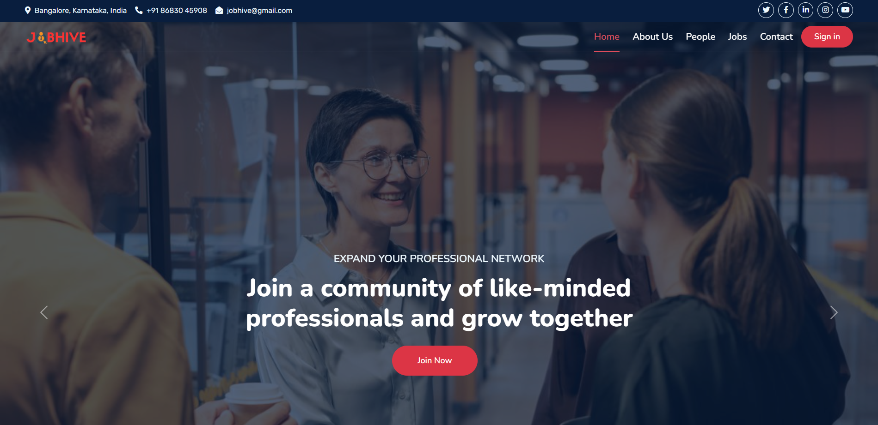

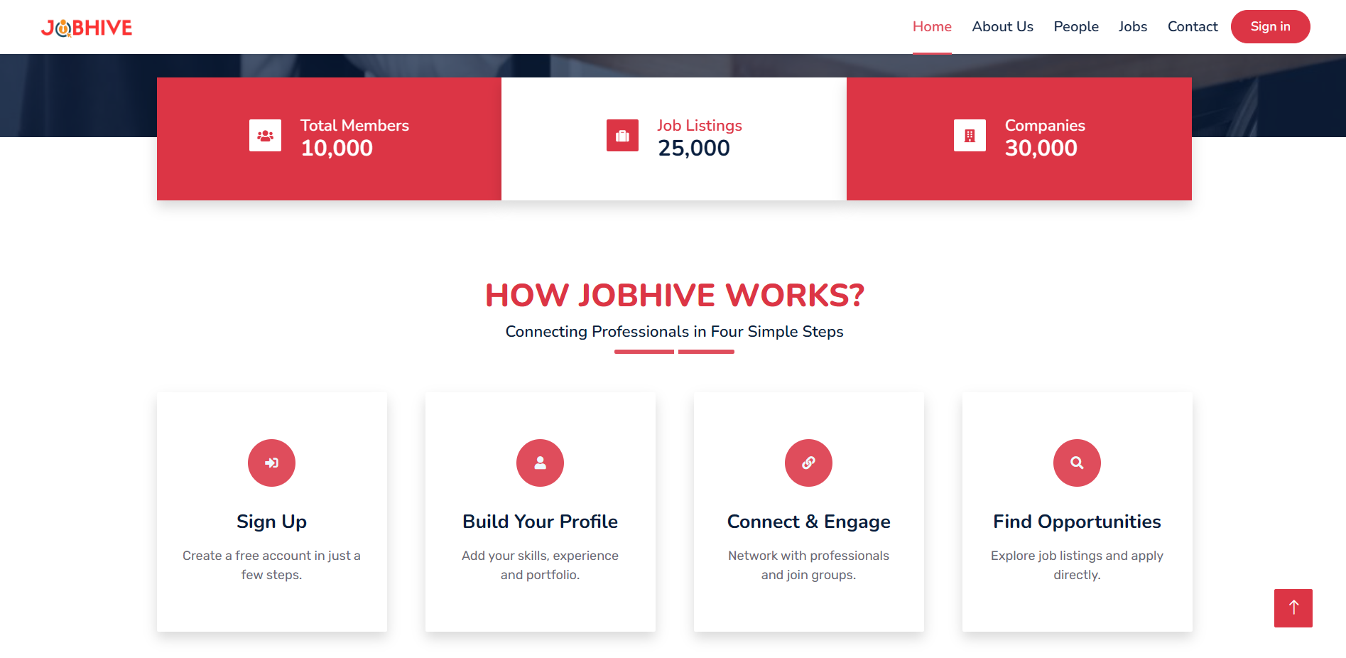





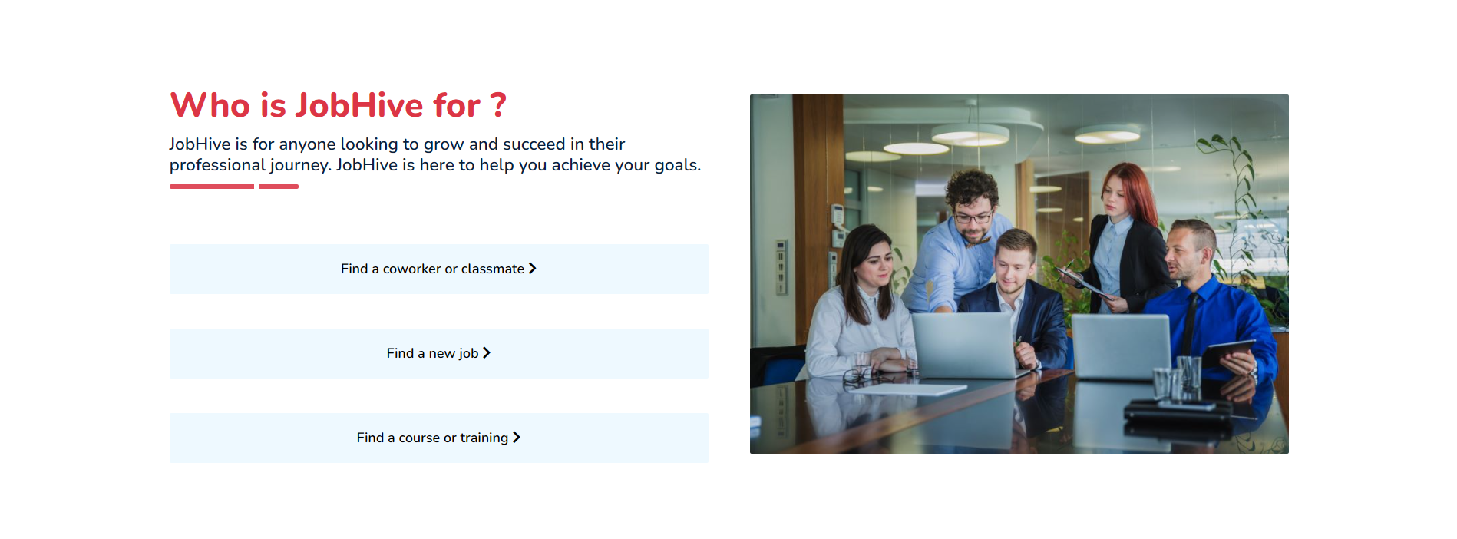



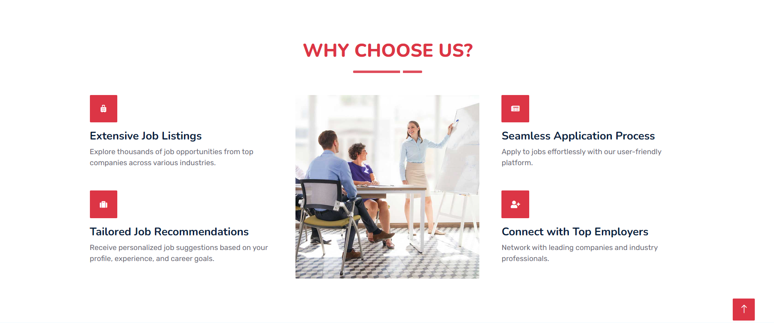





1. **About Us Page**

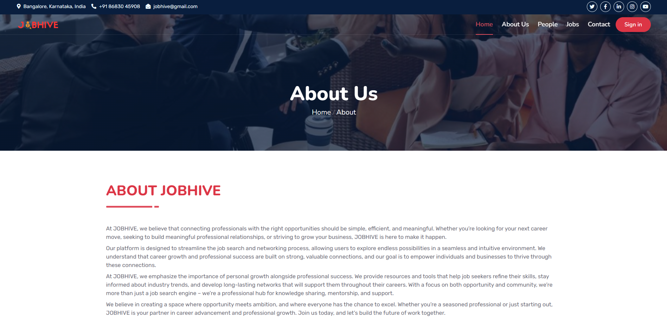

 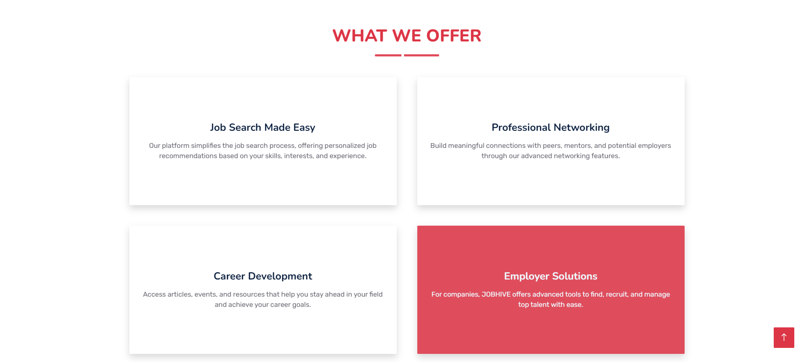 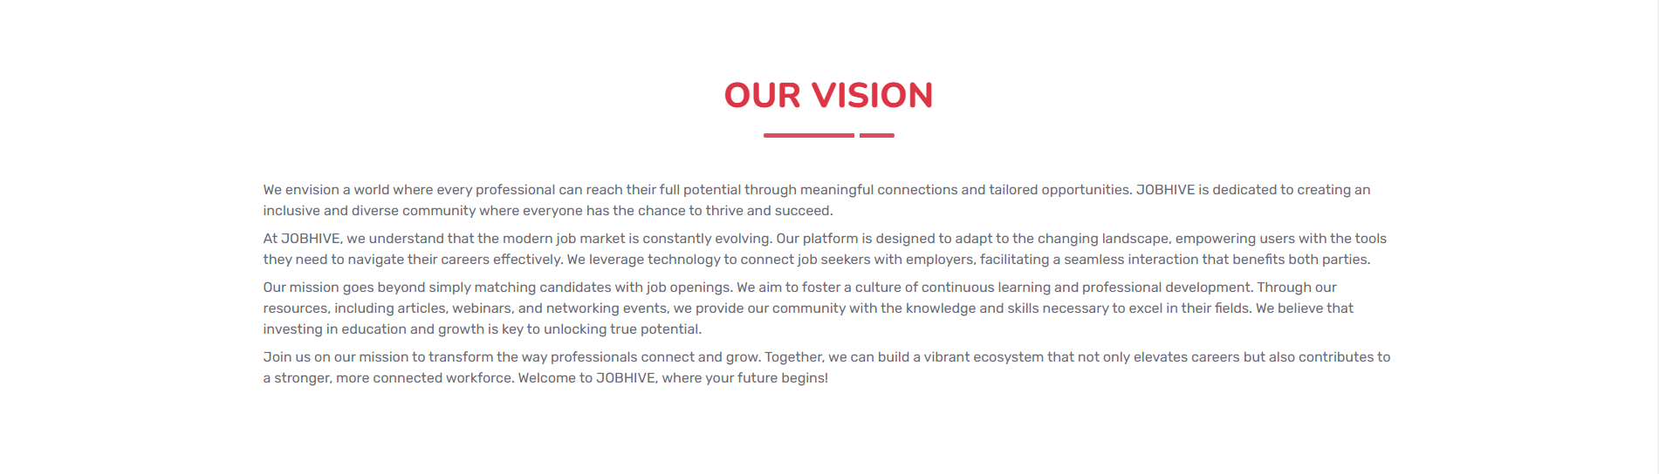 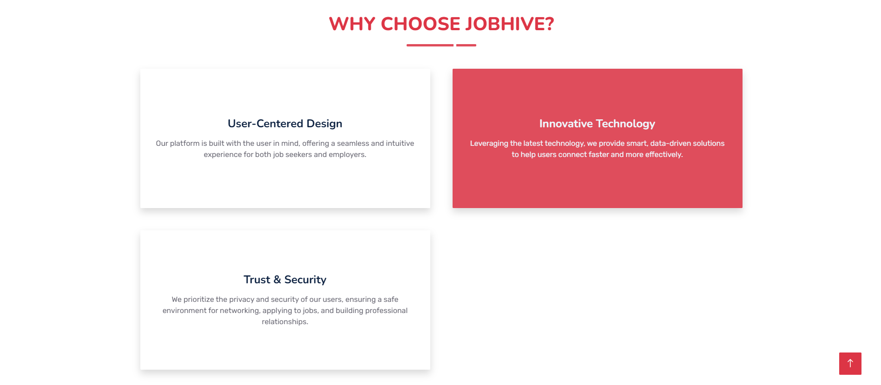



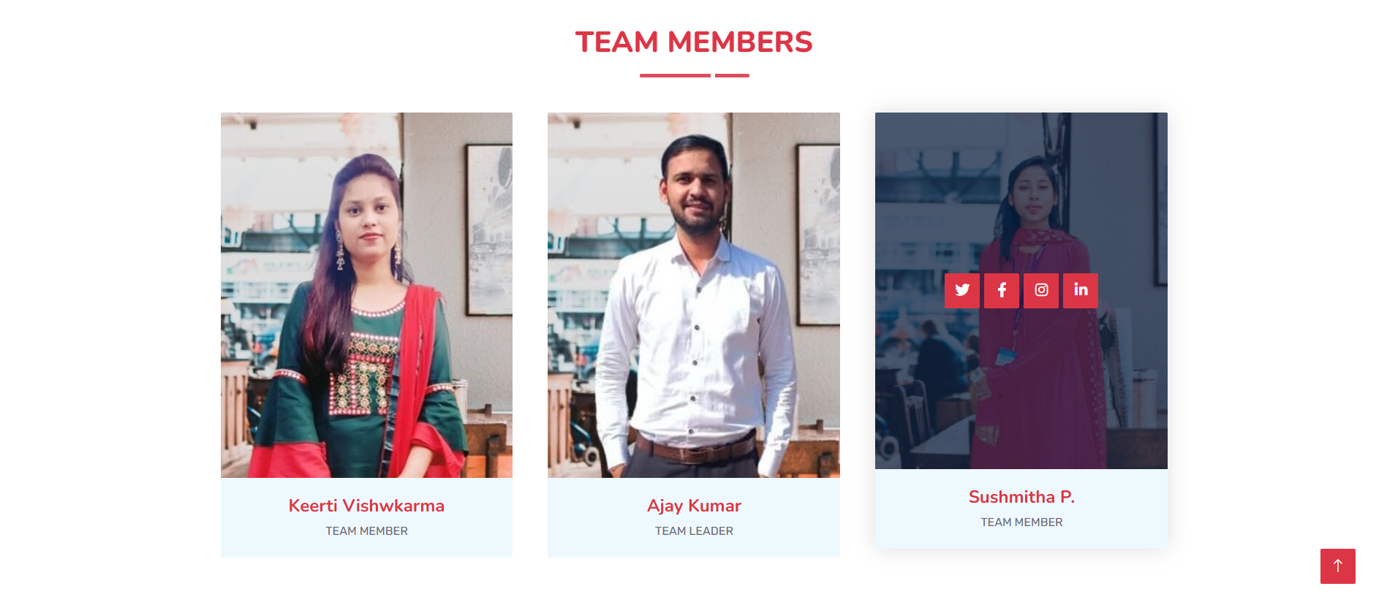



1. **Contact Us Page**

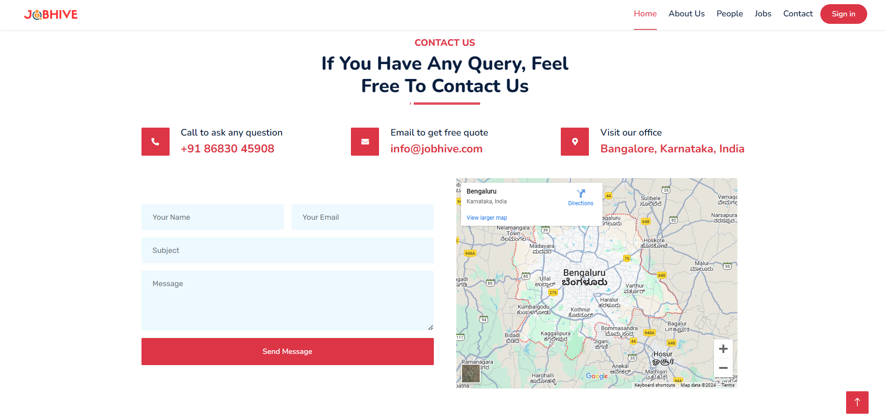

1. **Login Page**

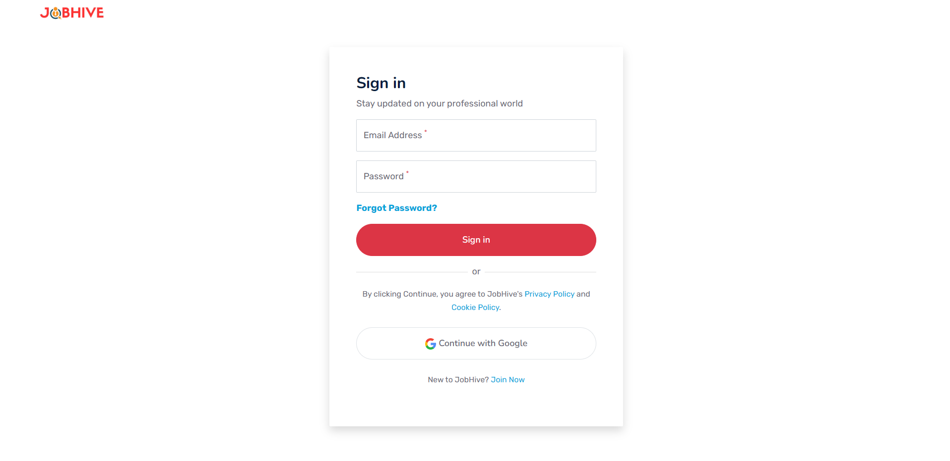

1. **Signup Page**

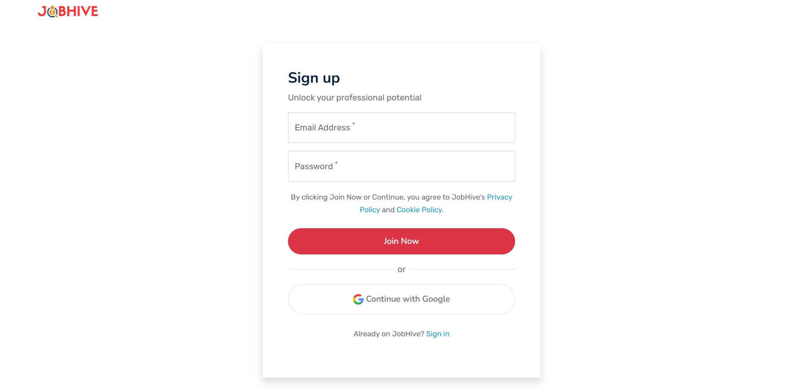

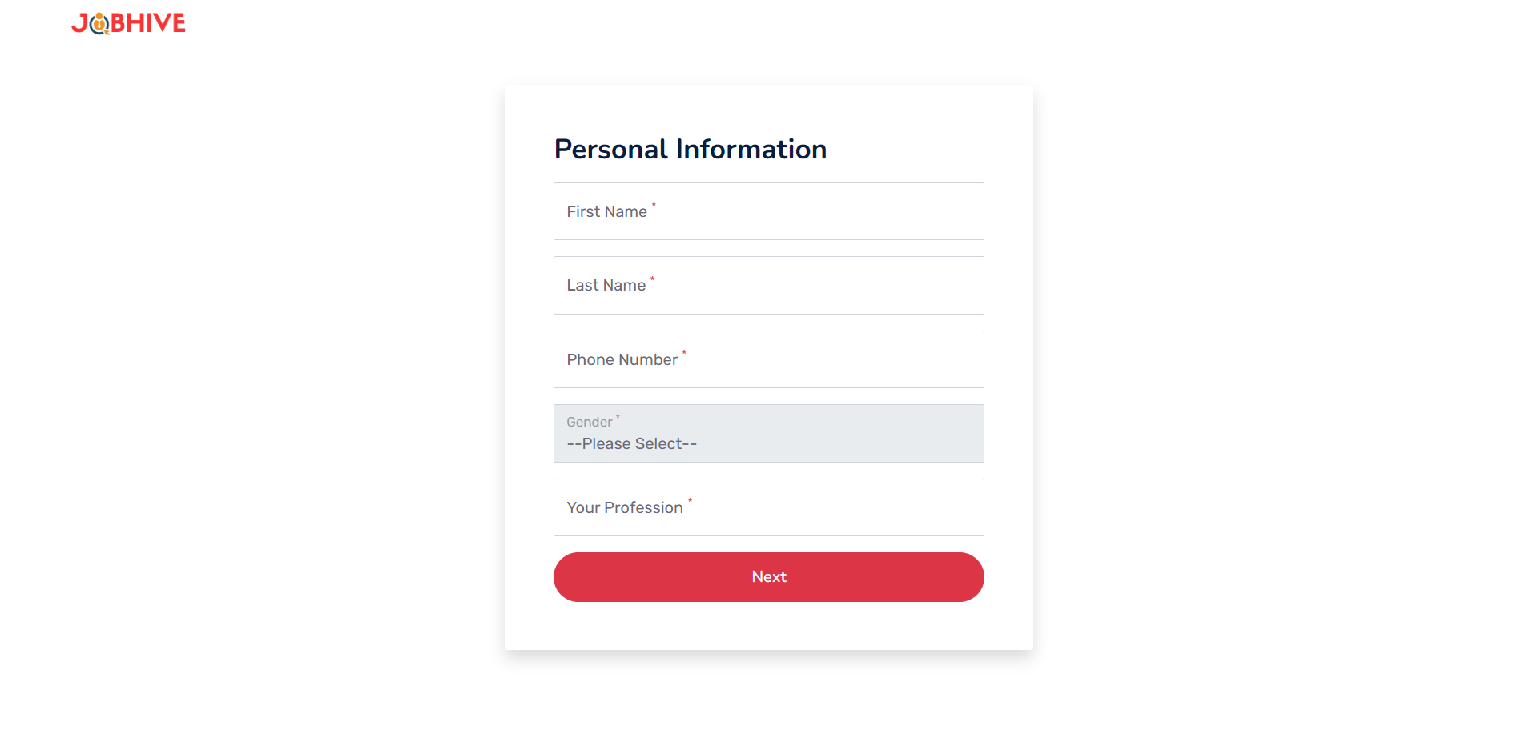

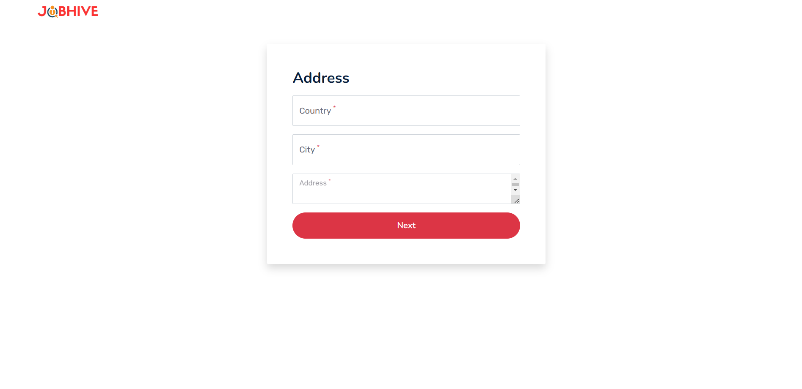

1. **After Login Homepage**

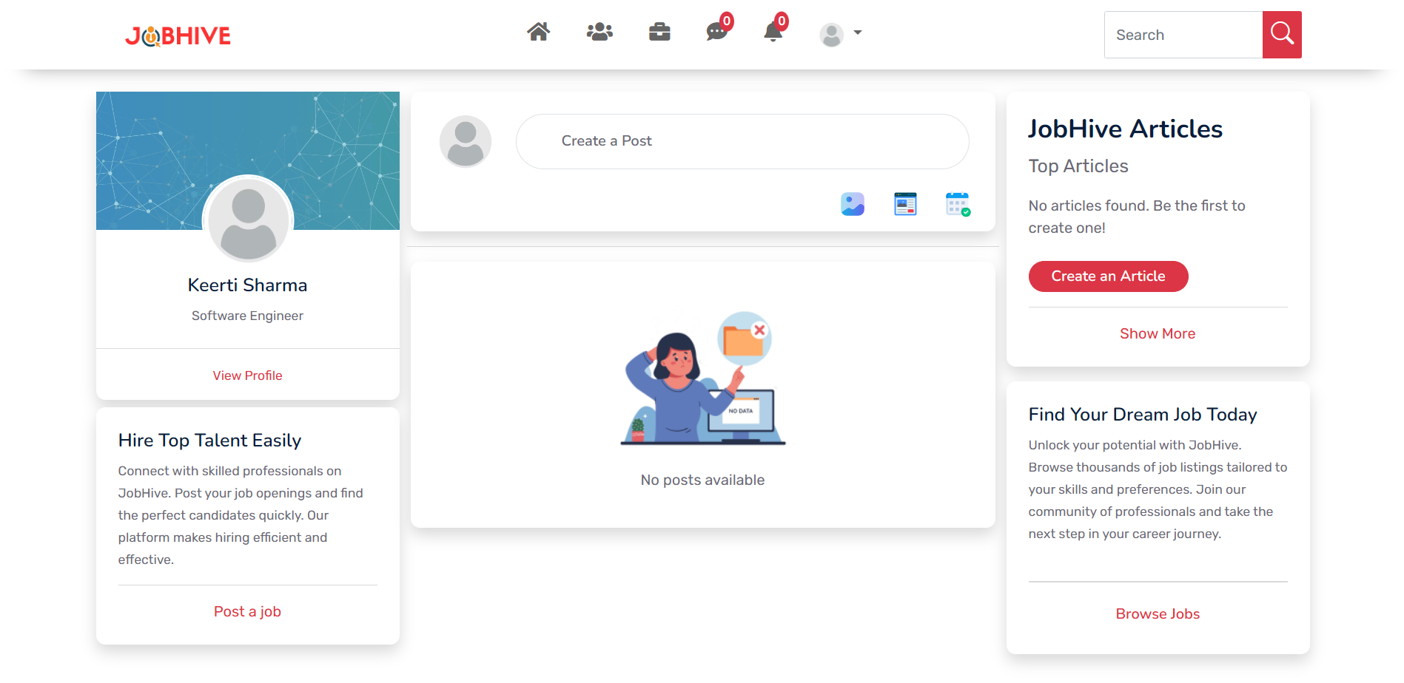

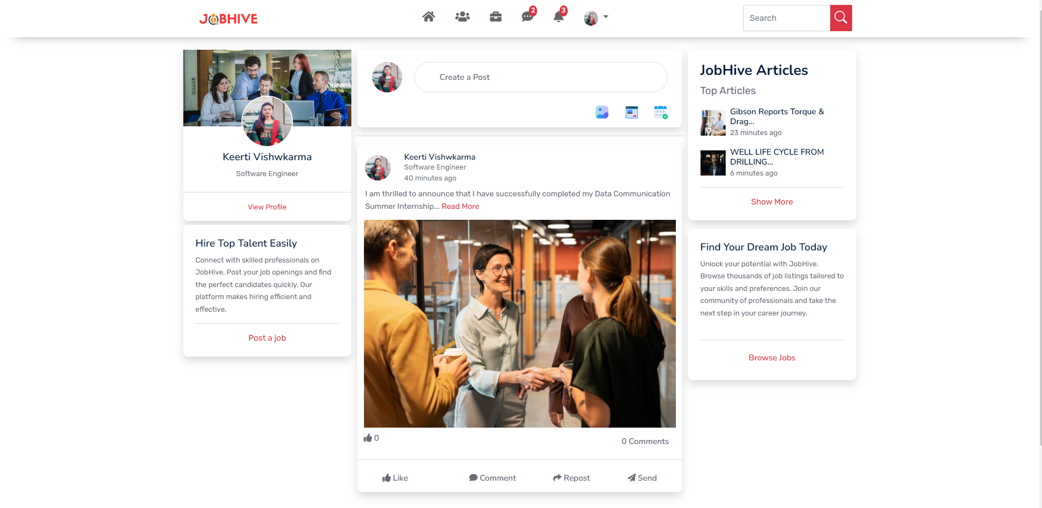

1. **Profile Page**

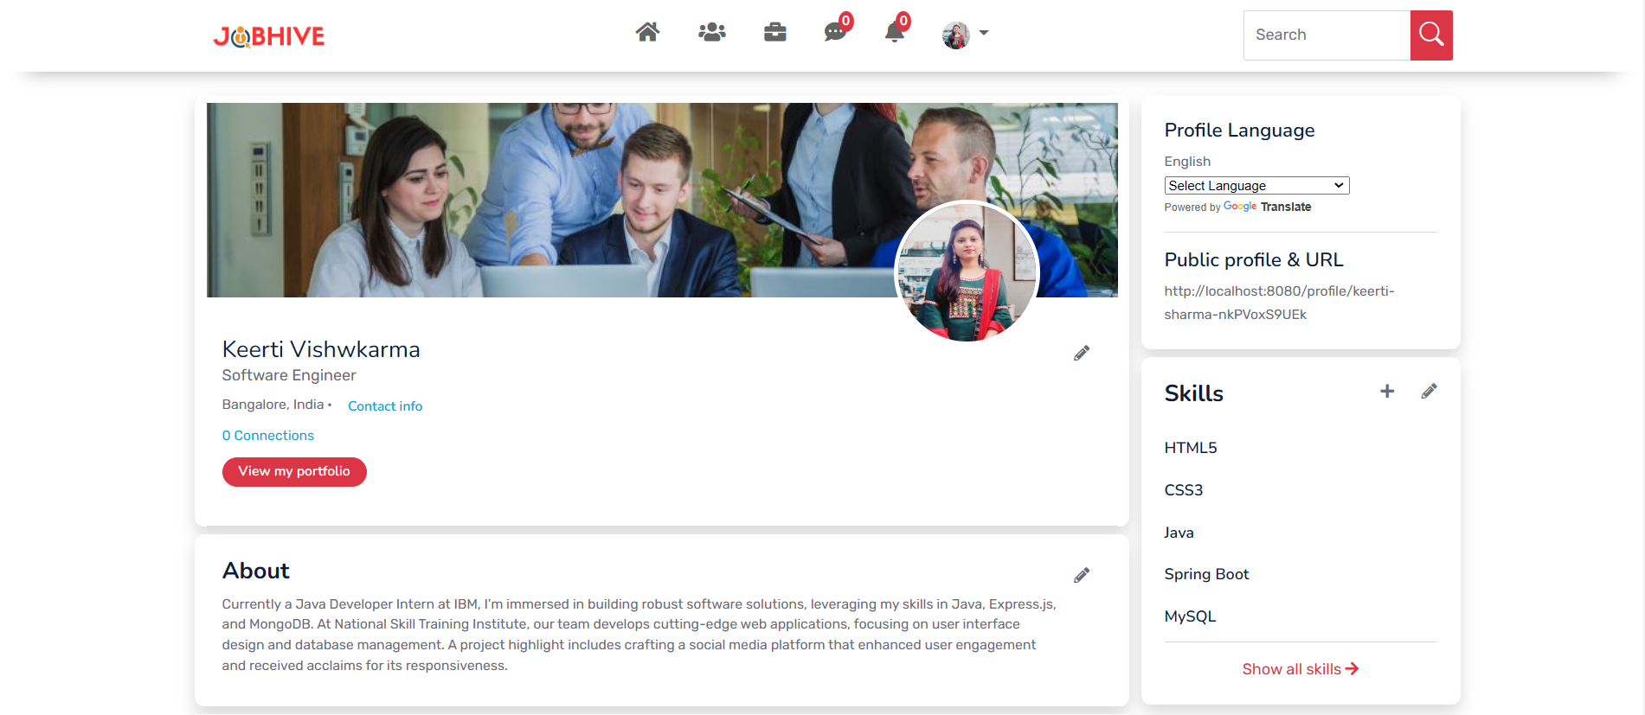

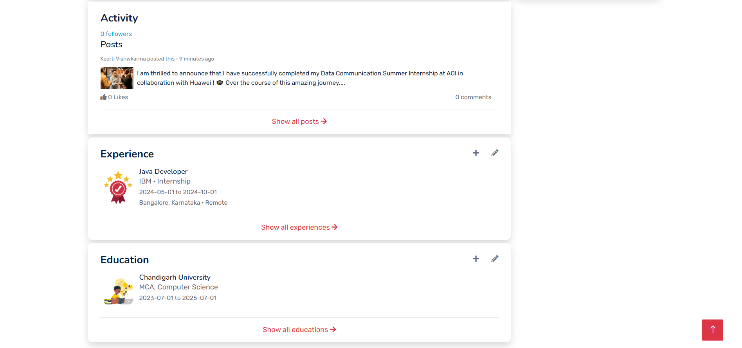

1. **Networks Page**

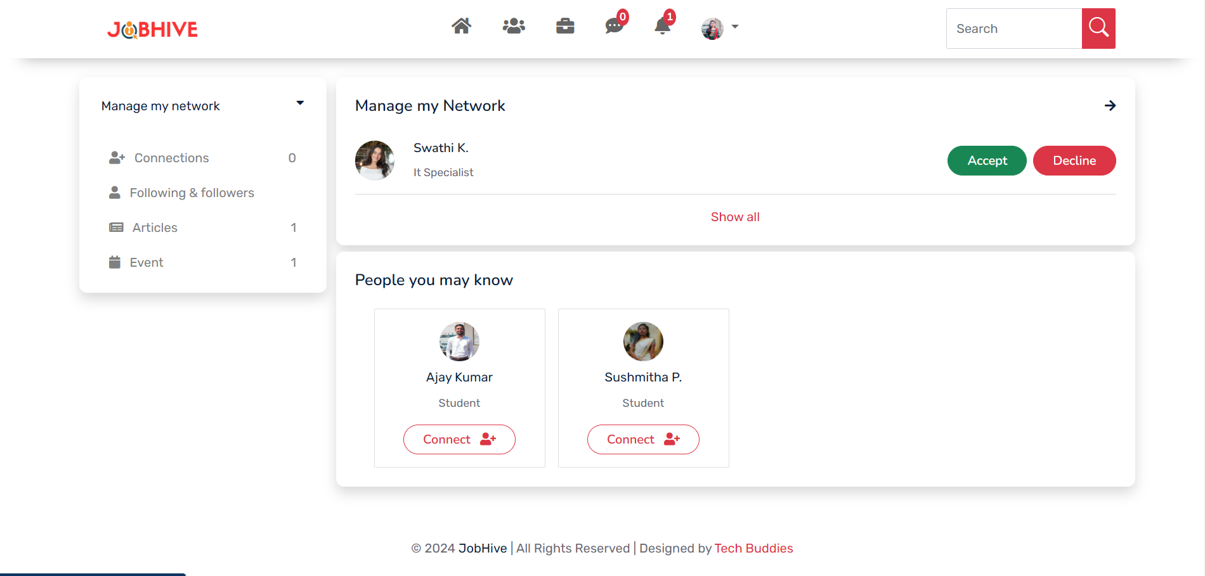

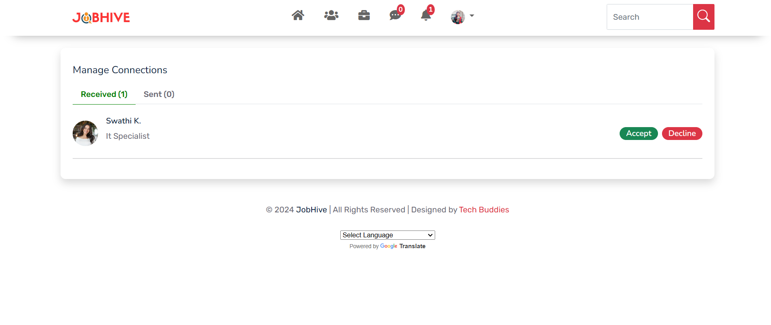

1. **Connection Page**

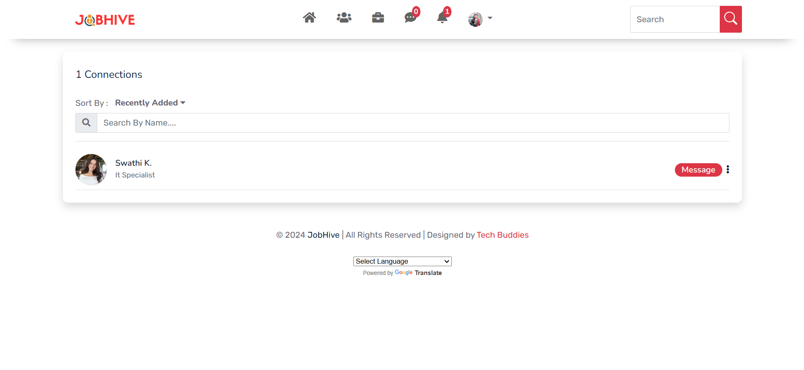

**10. Articles Page**

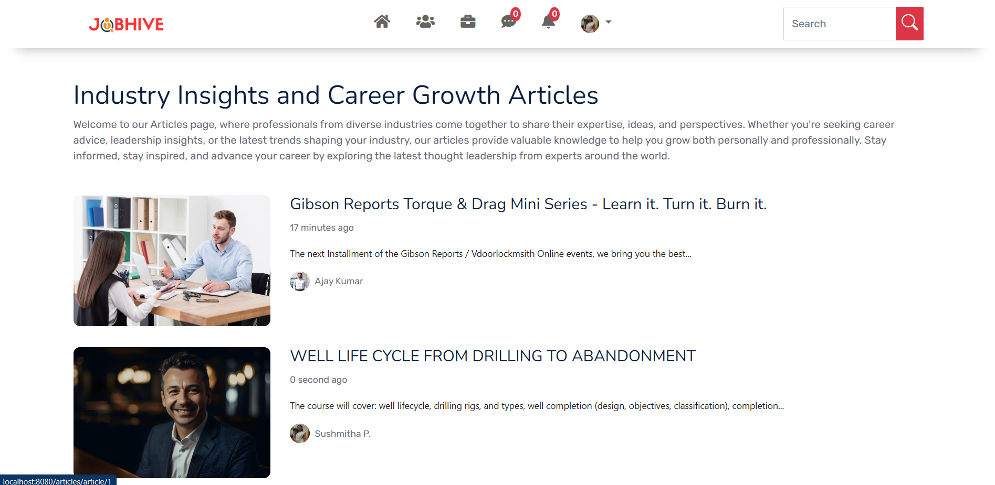

**11. Article Details Page**

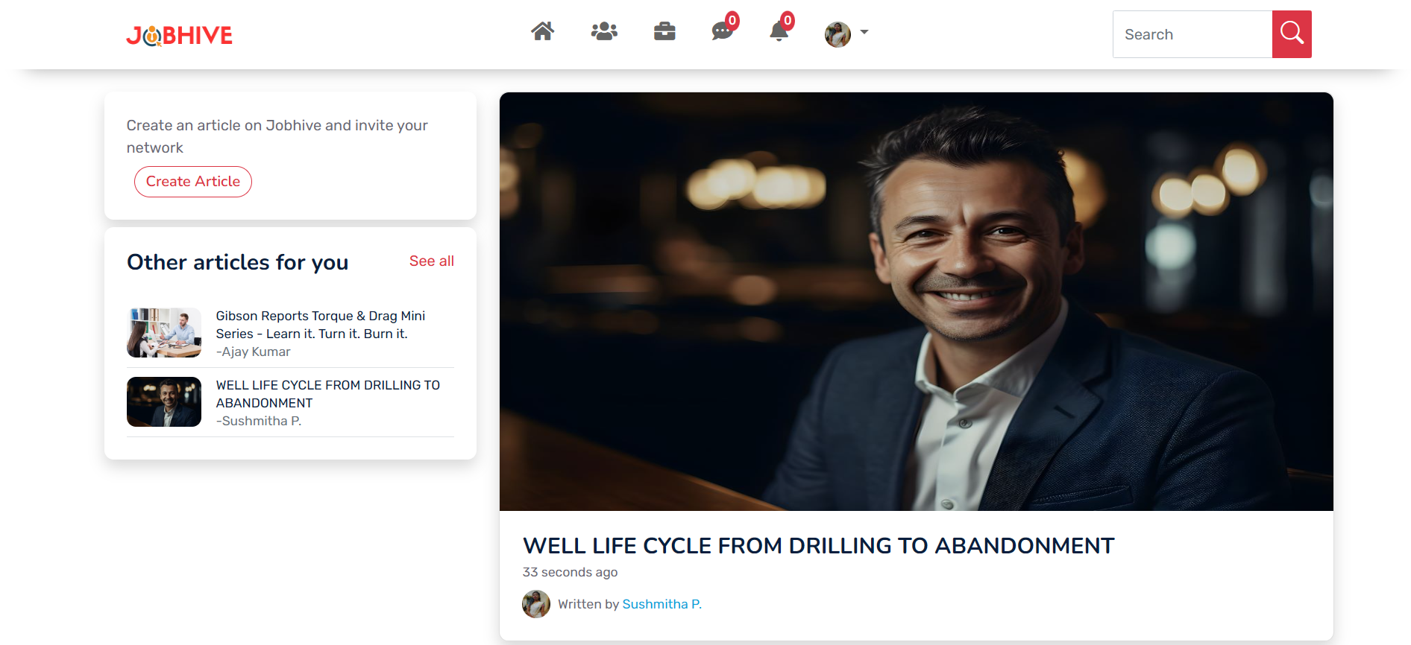

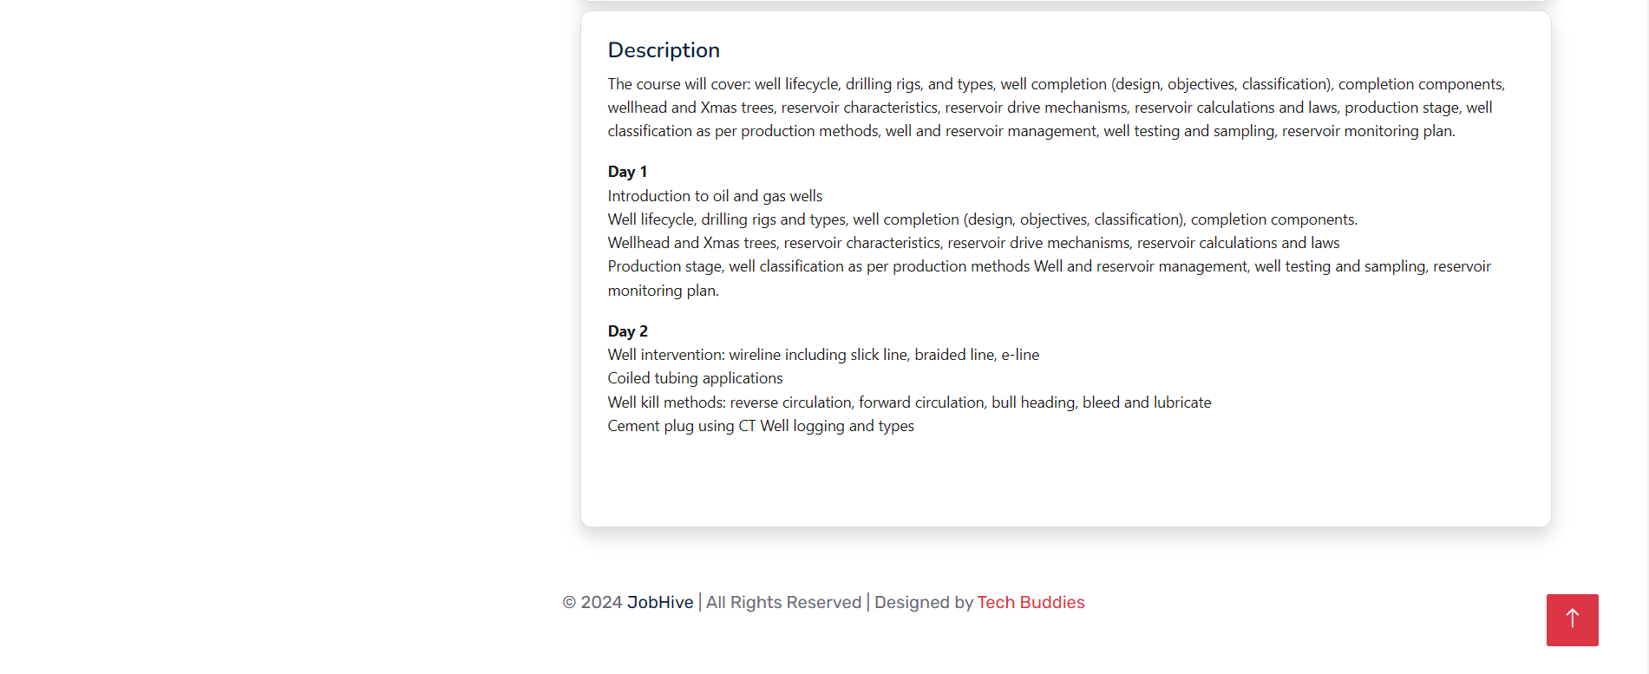

**12. Create Article Page**

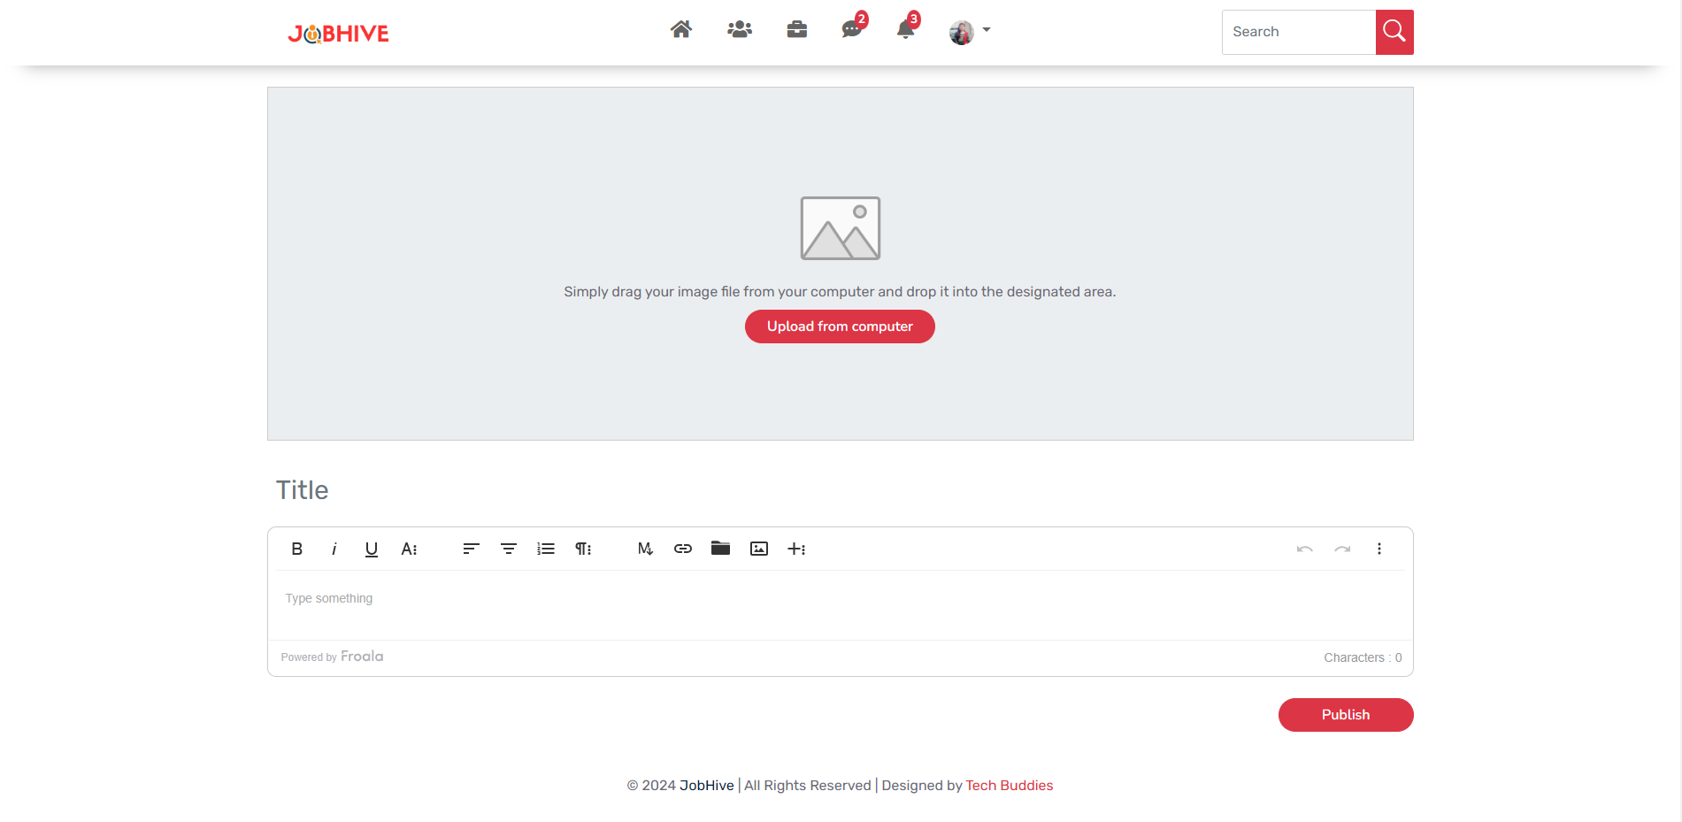

**13. Events Page**

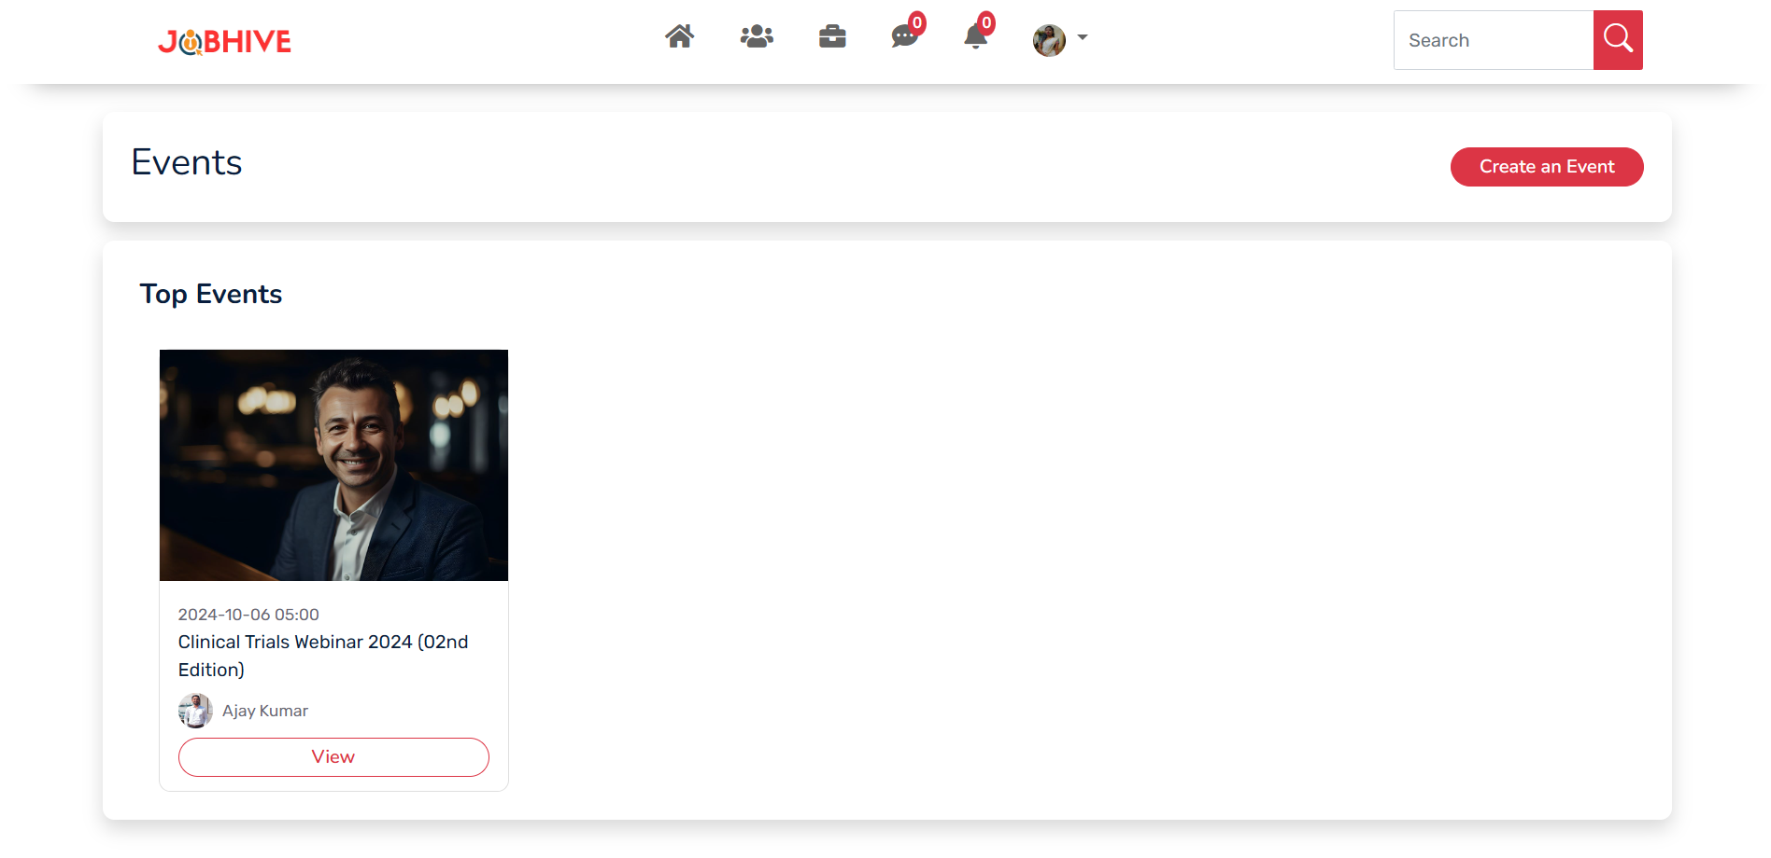

**14. Event Details Page**

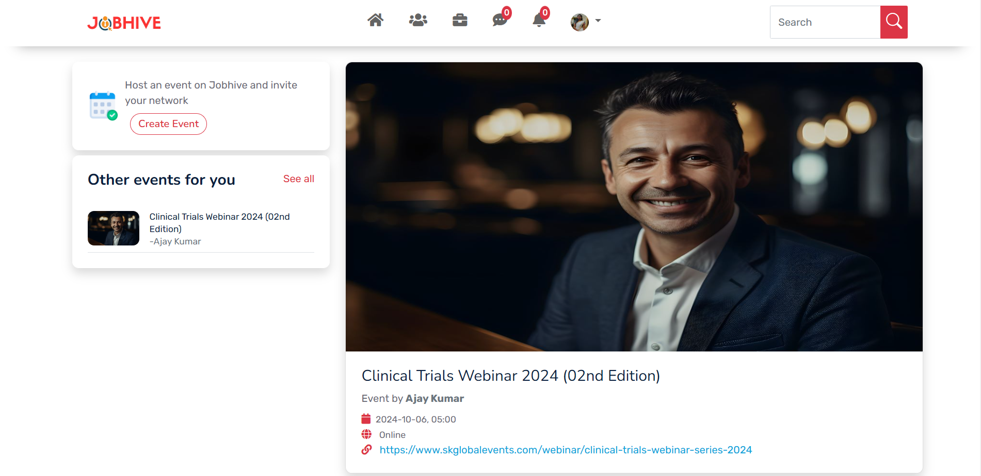



**15. Followers Page**

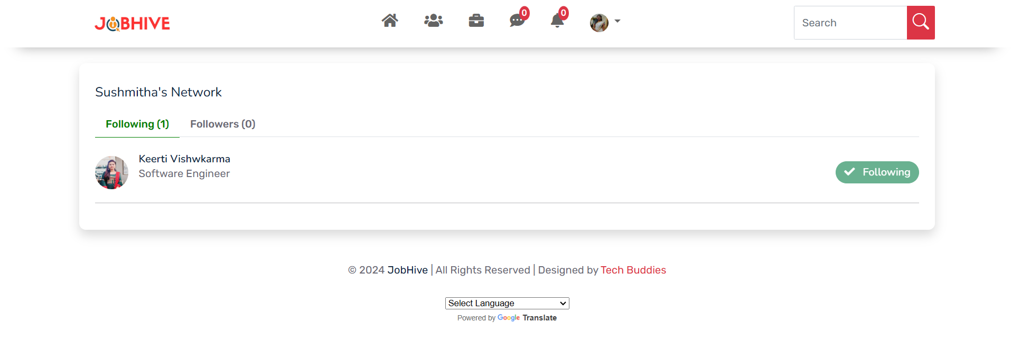

**16. Message Page**

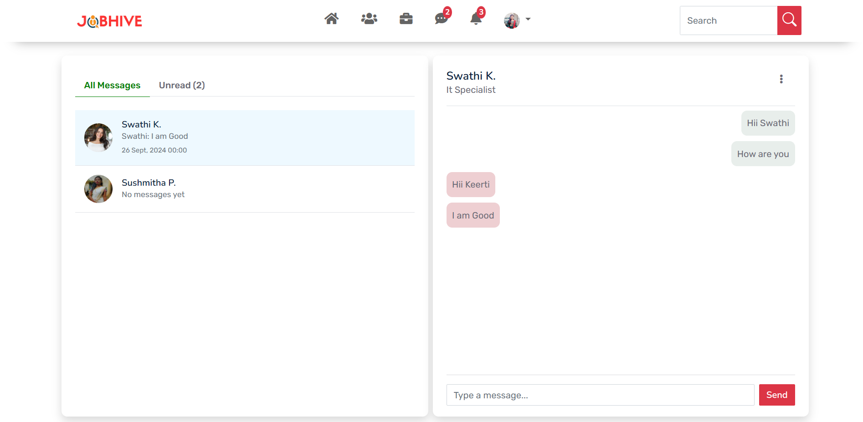

**17. Notifications Page**

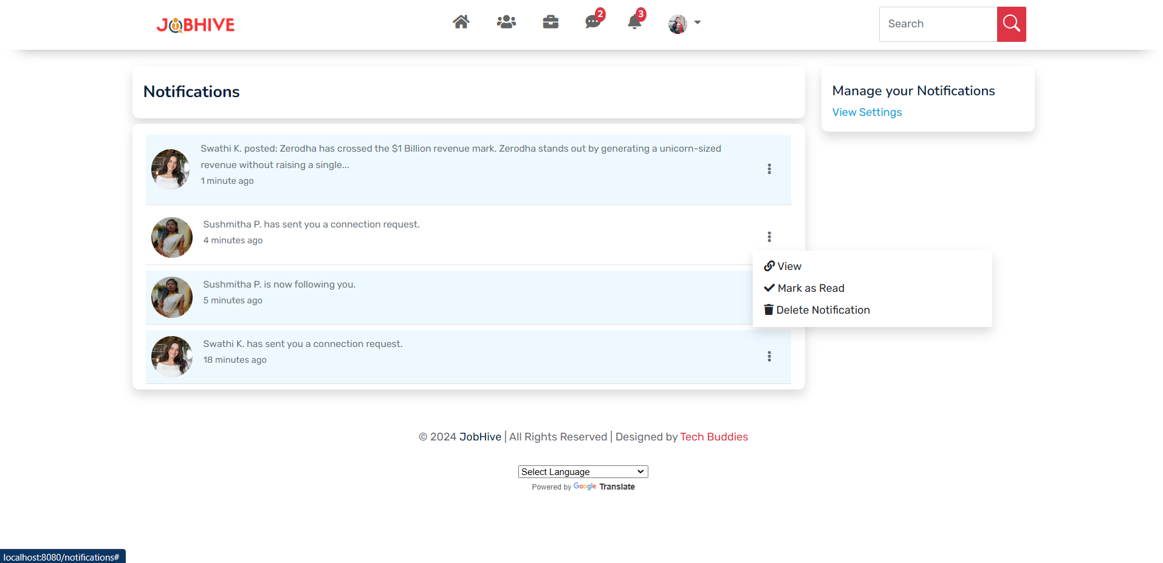

**18. Search Page**

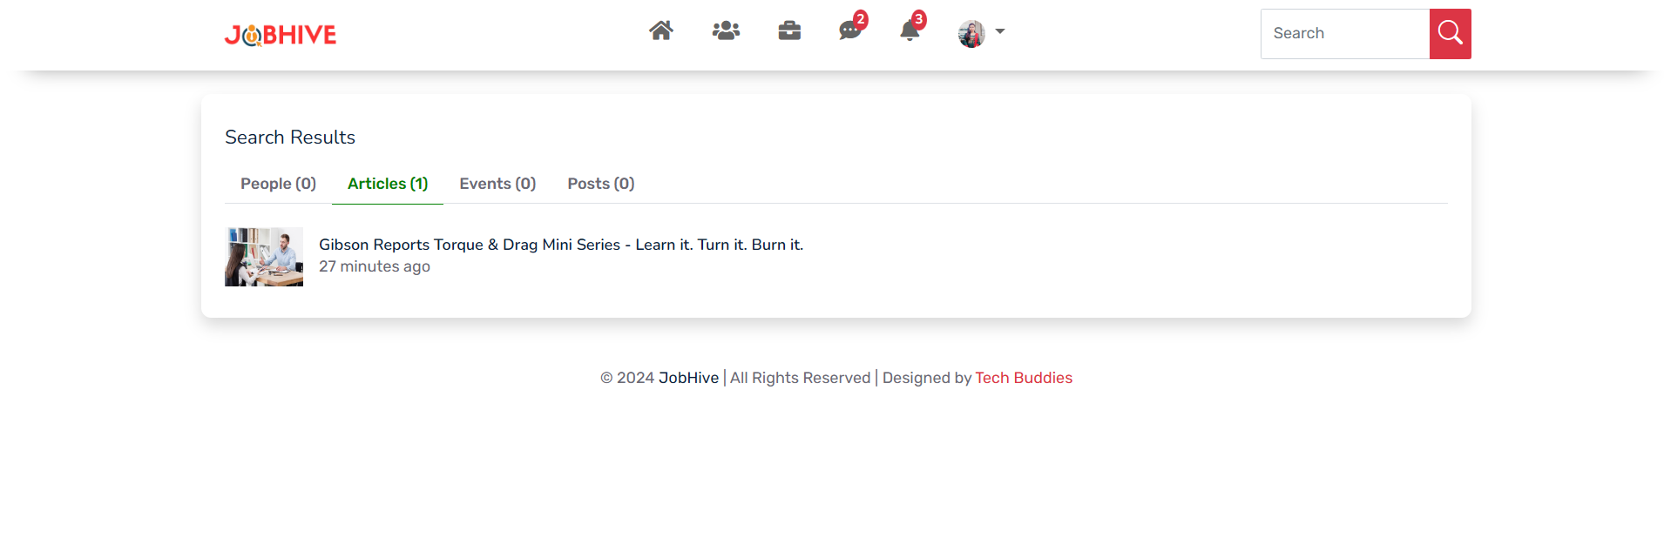

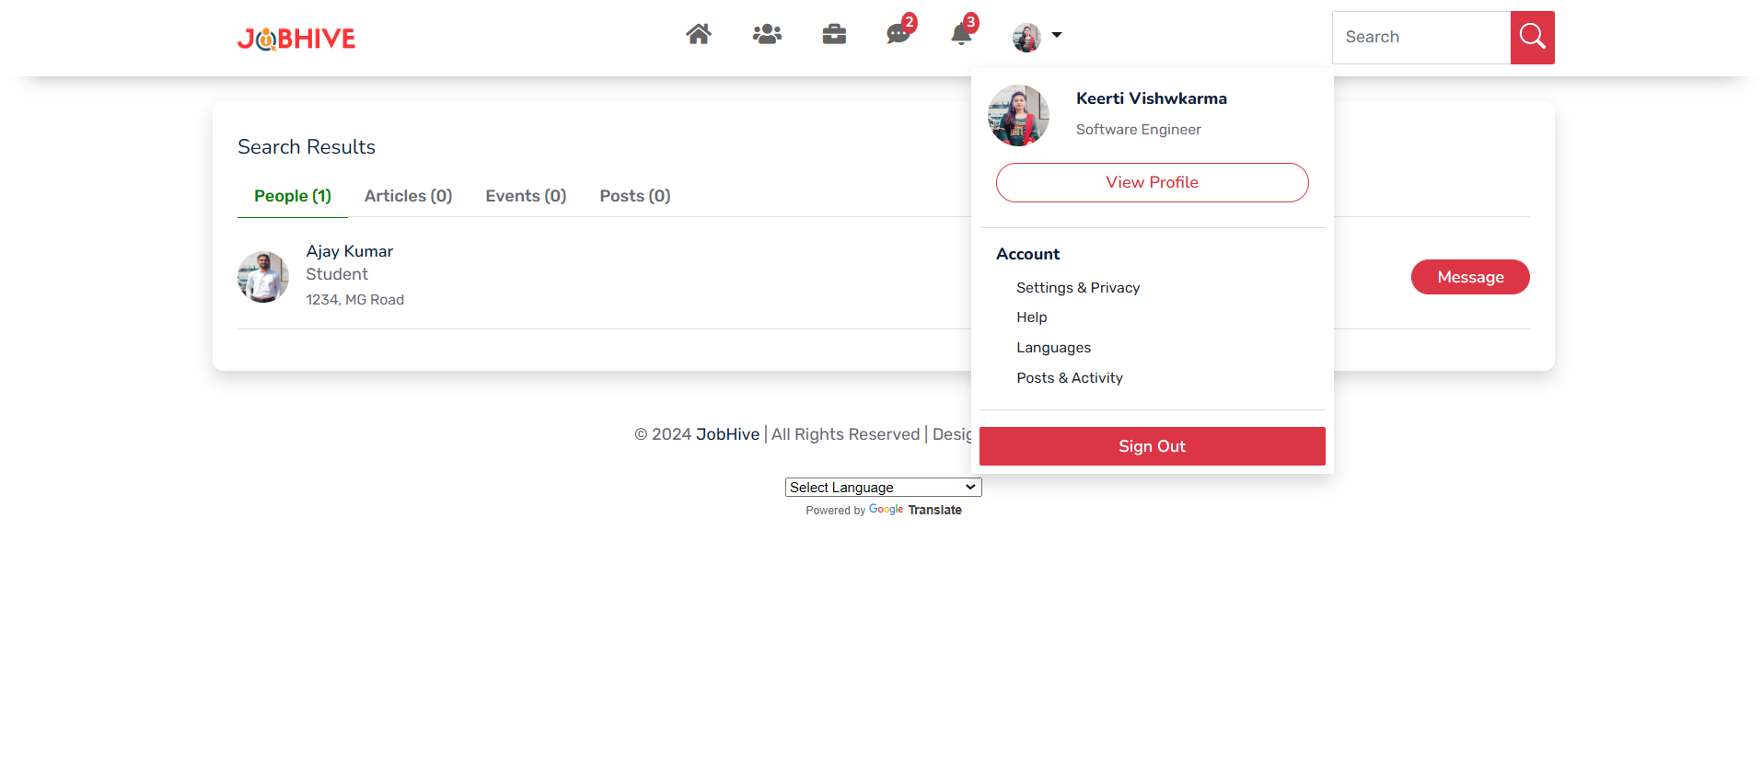

**19. Jobs Page**

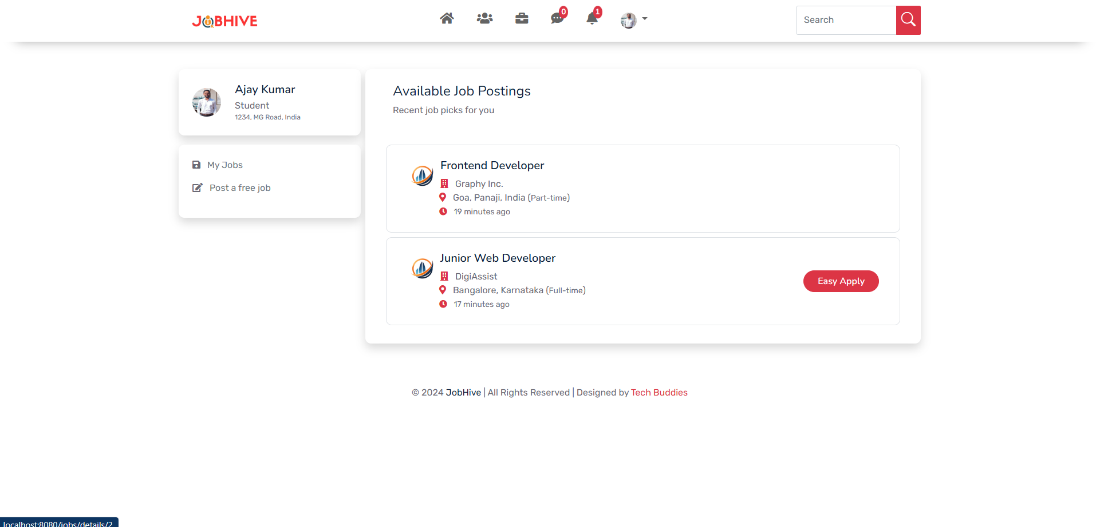

**20. Job Details Page**

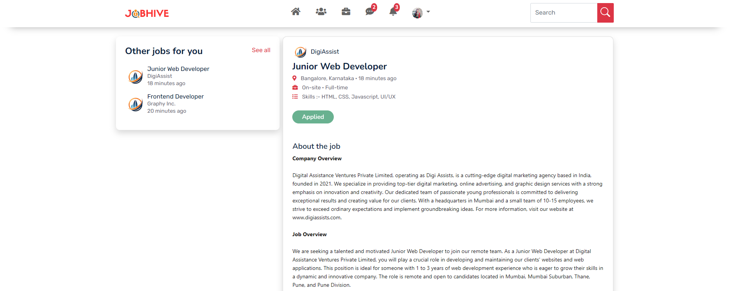

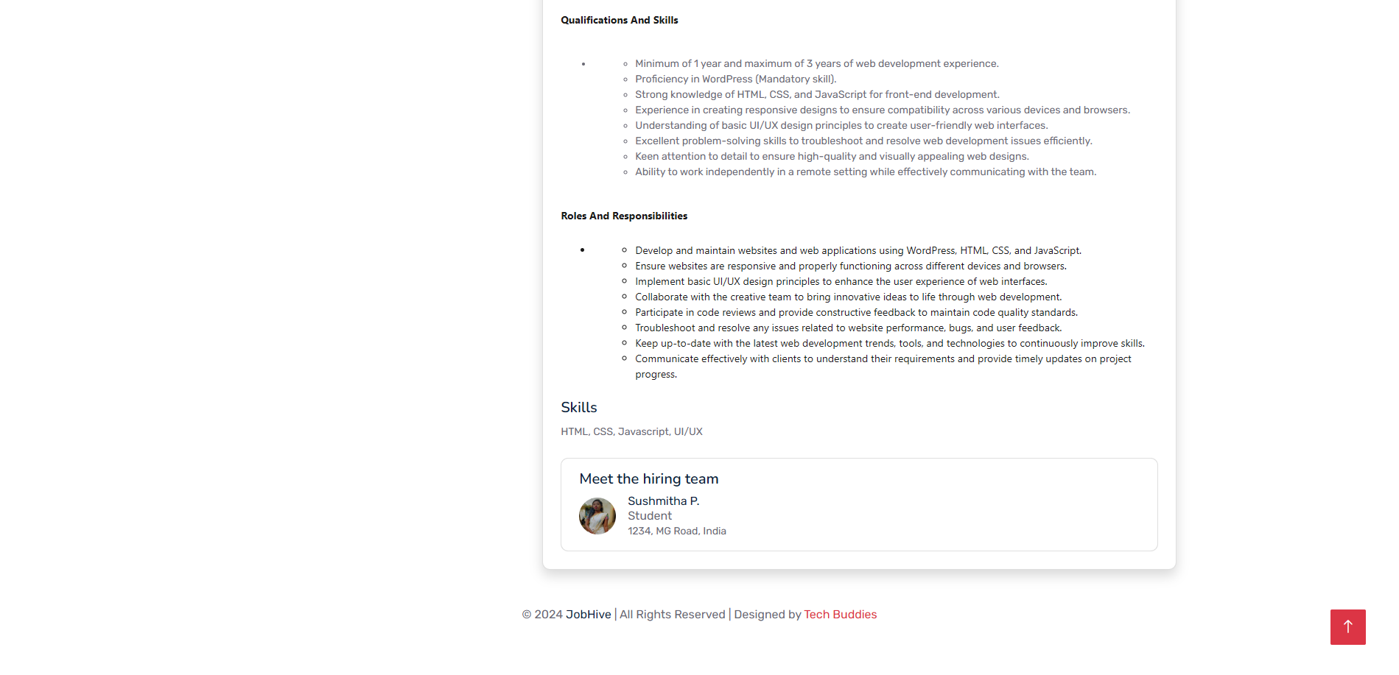

**21. Job Application Form**

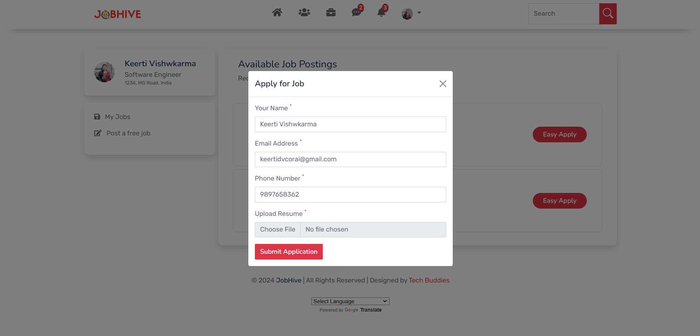

**22. My Jobs Page**

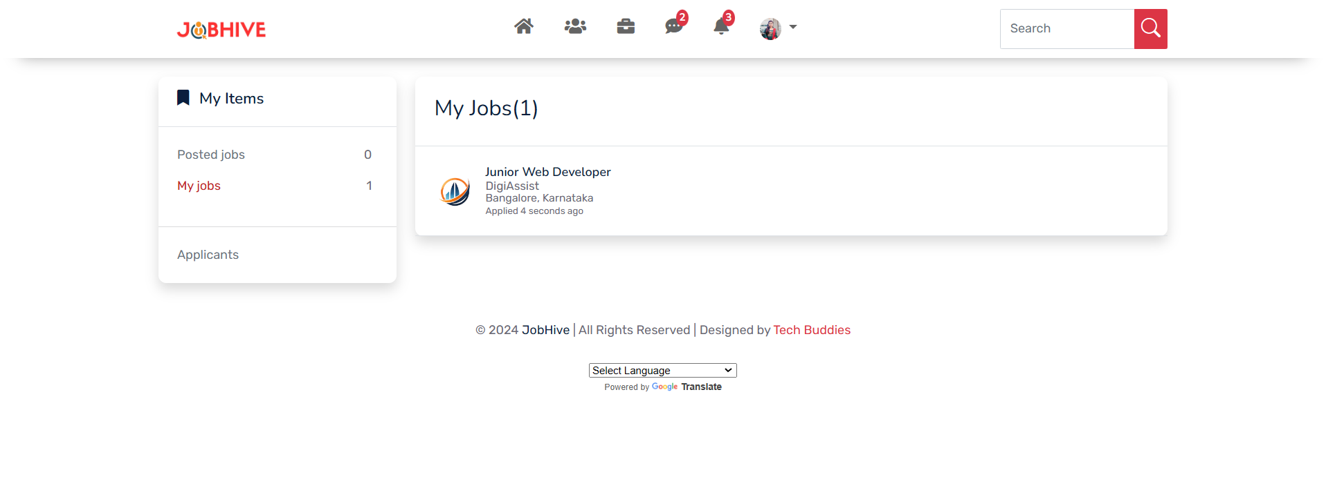

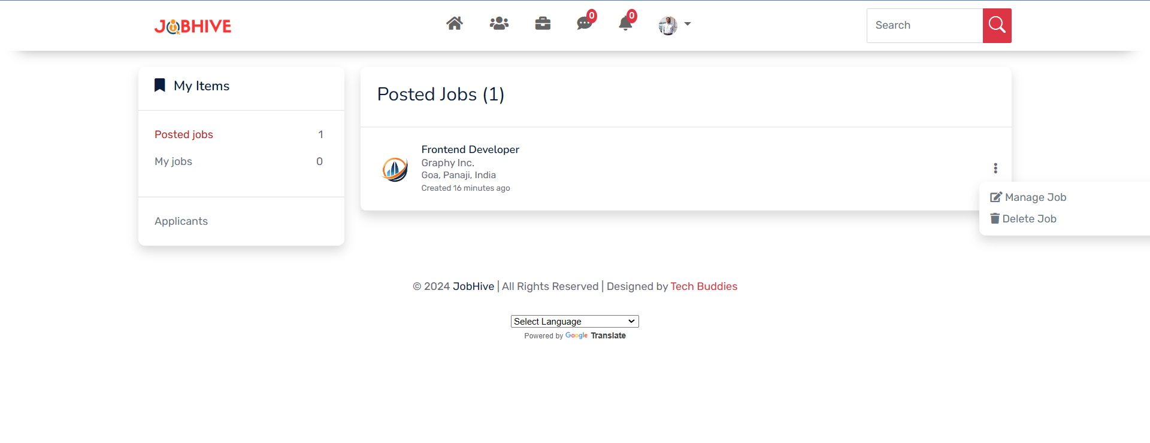

**23. Create Job Page**

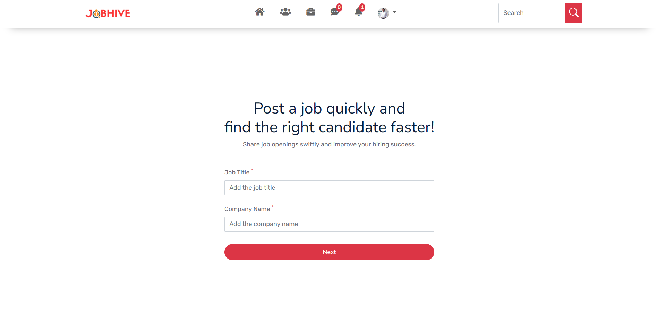

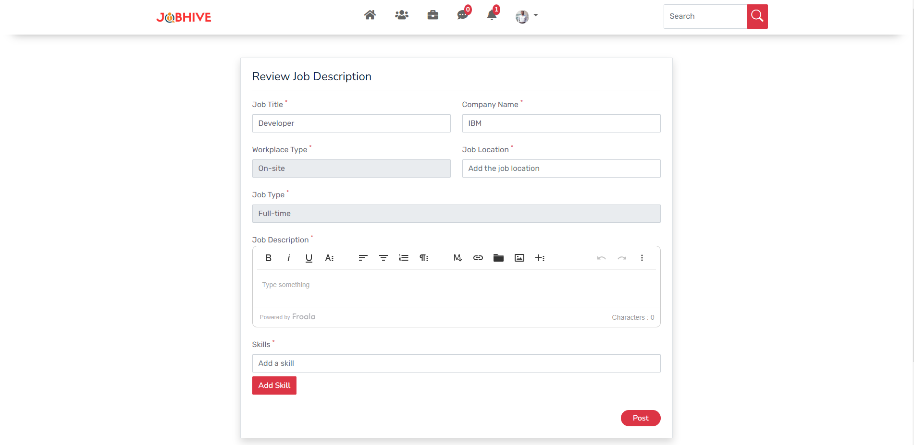

**Appendix C: Abbreviations**

1. **MVC** - Model-View-Controller
2. **JPA** - Java Persistence API
3. **API** - Application Programming Interface
4. **UI** - User Interface
5. **UAT** - User Acceptance Testing
6. **VPS** - Virtual Private Server
7. **CRUD** - Create, Read, Update, Delete
8. **REST** - Representational State Transfer
9. **MySQL** - Structured Query Language (a popular database management system)
10. **AI** - Artificial Intelligence
11. **ML** - Machine Learning
12. **FTP** - File Transfer Protocol
13. **SSH** - Secure Shell
14. **HTML** - Hypertext Markup Language
15. **CSS** - Cascading Style Sheets
16. **JWT** - JSON Web Token (for user authentication)
17. **Web Socket** - A communication protocol for full-duplex communication channels over a single TCP connection

**References**

1. **Spring Boot Documentation**

The official documentation for Spring Boot, providing comprehensive details on setup, configuration, and features.

[Spring Boot Reference Documentation](https://docs.spring.io/spring-boot/docs/current/reference/htmlsingle/)

1. **Thymeleaf Documentation**

Documentation for the Thymeleaf templating engine, covering syntax and usage for creating dynamic web applications.

[Thymeleaf Documentation](https://www.thymeleaf.org/documentation.html)

1. **Bootstrap Documentation**

Official documentation for Bootstrap, offering guidelines for responsive design and components.

[Bootstrap Documentation](https://getbootstrap.com/docs/5.3/getting-started/introduction/)

1. **MySQL Documentation**

Detailed information on MySQL, including installation, configuration, and usage.

[MySQL Documentation](https://dev.mysql.com/doc/)

1. **Java SE Documentation**

The official documentation for Java Standard Edition, providing resources on the Java programming language and its APIs.

[Java SE Documentation](https://docs.oracle.com/en/java/javase/)

1. **Hostinger Knowledge Base**

A collection of articles and guides for hosting services, including setup and configuration for Java applications.

[Hostinger Knowledge Base](https://support.hostinger.com/en/)